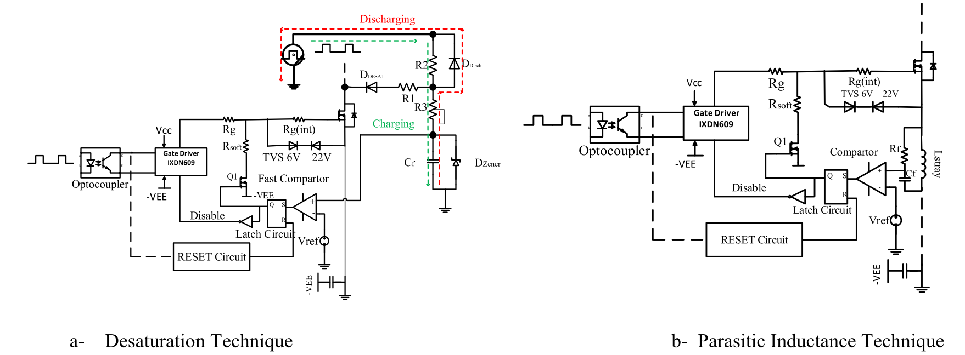

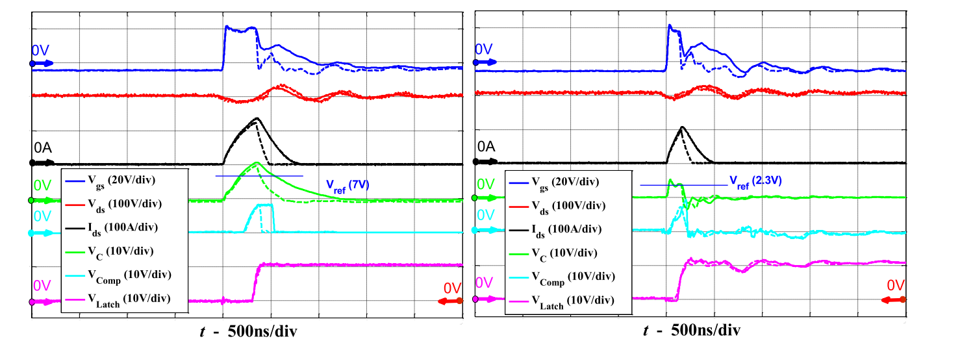

1. Desaturation Technique (b) Parasitic Inductance Technique

* Parasitic inductance technique detects fault 2 times faster
* Desaturation technique requires fast and low Coss diodes
* The current can be limited in lower level with parasitic inductance technique
* Desaturation technique has less distorted node voltages

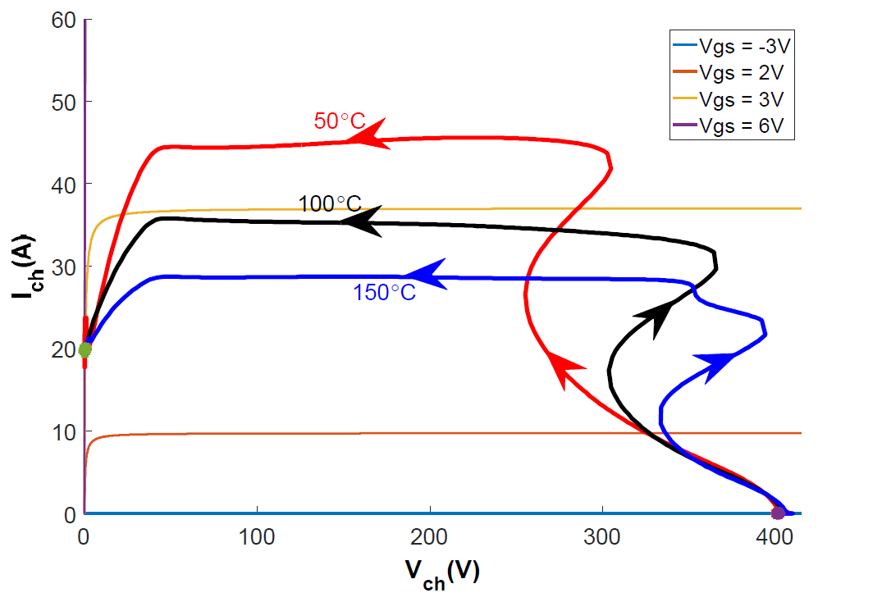

For GaN transistor with loop inductance of 7 nH

@ 150֯C - di/dt is nearly 8.6 A/ns

@ 100֯C - di/dt is nearly 12.8 A/ns

@ 50֯C - di/dt is nearly 21.4 A/ns